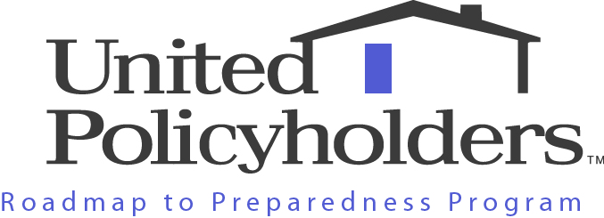

United Policyholders (“UP”) is a source of useful insurance information and a respected voice for consumers in all 50 states.

Our unique preparedness tips and tools are based on lessons learned by disaster victims about actions they wish they’d taken before their loss plus advice from experts. UP has twenty years of experience and a strong track record of integrity and value. We don’t accept financial support from insurance companies and we don’t sell insurance. We do help home and business owners make good buying choices and maximize their insurance protection.

Many of our staff and volunteers lost a home in a disaster and navigated the road to recovery with our help. Our professional advisors include leading experts in firefighting, construction, insurance and the law from all over the United States. For more information visit our website at www.uphelp.org.

Taking a few simple steps to minimize damage and prepare to recover from wildfires, quakes, high winds and heavy rain makes good financial sense and we’re here to help you do that:

TIPS FROM THE TRENCHES

These tips are based on real life lessons, including:

- What disasters victims wish they’d known about insurance before they had a loss
- How to avoid the most common gaps in financial protection
- What helps fire fighters save homes during wildfires and after earthquakes

Tip #1: Insurance money -- not charitable or government aid makes the biggest difference in people’s ability to rebuild and recover after a disaster. FEMA money is needs-based and the maximum grant is $25k. SBA loans take time and have to be repaid. Charitable aid generally covers basic needs – not the cost of rebuilding a home.

Tip #2: Having enough insurance to rebuild your home is so important. Repairing and rebuilding after a disaster is hard, but if you have enough insurance you can do it. Problem is: many disaster victims find out the hard way they’re underinsured

Tip #3: Don’t blindly trust that your insurance company has got you fully covered. The amount of insurance you need is the amount it would cost to rebuild your home, not its real estate value. When your agent or insurer promises you’re protected, confirm that and keep a good record in a safe place. And consider getting a second opinion from a contractor, professional estimator or use specialized software like HM Facts.com to run the numbers yourself. Read UP’s Home Insurance Buying Tips at www.uphelp.org

Tip #4: Complete as much of the UP Home Inventory as you can, then store the records off site in a safe place. Hopefully, you’ll never need it, but if you do, you’ll be so glad you created an inventory. Do it now!

Tip #5: Find out what your local risks are, aim to cover them. Most policies exclude flooding, earth movement, earthquakes mudflow and landslide damage. Some exclude high winds/hurricanes. You have to pay extra to buy the coverage separately. Tailor your insurance to your property and your location.

Tip #6: Take advantage of insurance discounts for making your home safer. Some companies offer discounts to people who “retrofit” and make their property more resistant to damage. For example, if you install special shutters or a valve that shuts off your gas in the event of an earthquake, most home insurers will discount your premium.

Tip #7: Avoid letting your insurance lapse. If money is tight, raise your deductible to bring down the cost of your policy.

Tip # 8: Don’t panic if your insurer drops (“non-renews”) you. Read UP’s publication “Dropped by Your Insurer?” Ask your local Fire Department if they’ll inspect and certify for an insurance company that you’ve cleared brush adequately.

Tip # 9: Clear brush around your home and keep it clear. The #1 thing that helps fire fighters save homes is “defensible” (clear of brush) space. Clear out gutters and roof drains regularly. Install screens on roof vents to keep embers from flying in and spark arrestors in chimneys. Get your chimney cleaned professionally and regularly.

Tip # 10: Have an evacuation plan that includes “grab and go” or off-site access to important documents. Keep a copy of your policy in a safe place away from your home and better yet, scan the complete document onto your computer or onto a UP Roadmap to Preparedness flash drive.

ROADMAP TO PREPAREDNESS RESOURCES

Selected items UP’s free online library:

- Dos and Don’ts When Insuring Your Home
- The Big One and the Big Question…EQ Insurance: To Buy or Not to Buy…
- UP Insurance Comparison Guides

Tools:

- The UP Home Inventory Preparedness Flash Drive
- The UP EQ Insurance Shopping Guide

The United Policyholders Home Inventory Preparedness Flash Drive will help you stay one step ahead of Mother Nature by documenting your household belongings before disaster strikes.

Workshops and Presentations:

United Policyholders offers preparedness education and insurance literacy workshops and presentations in California to help individuals and businesses apply lessons learned from previous catastrophic disasters. To schedule a workshop or presentation, email info@uphelp.org.

